**Cart Consultants Project Management Toolkit User Manual**

**First Edition**

**Group 27**

**Compiled by: The Cart Consultants Team**

# Table of Contents

Table of Contents 2

1. Introduction 3

1.1. Background of the application 3

1.2. Purpose of the application 3

1.3. System Capabilities 3

2. Using the system 4

2.1. Installing the Application on your system. 4

2.2. Starting up the system 7

2.3. Logging in 7

2.4. Creating an Account 8

2.5. The Project Selection and creation page 9

2.6. Project Detail Page 10

Project Initiation Tab 11

Project Planning Tab 12

Project Execution Tab 13

Project Closure Tab 14

3. Using the applications project Management features 14

3.1. Components used within the system 14

2. Opening exported documents 16

3.2. Printing Documents 20

4. The suggested process to be followed when utilizing the application. 21

Step 1: Log in to the system 21

Step 2: Select the project you wish to work on or create a new project: 21

Step 3: View and edit document contents of each phase 21

Step 4: Tracking project progress 23

Step 5: Sync information to Online Database 23

5. Possible errors that could be encountered 24

7. Conclusion 25

# Introduction

We thank you for using the Cart Consultants Project Management toolkit created for the purpose of assisting new project managers with learning how to properly and efficiently perform project management. The MPMM project Methodology is the main methodology that is supported by this toolkit however additional project toolkits can be added upon request.

## Background of the application

The client created an application in the access database system that guided the user through the process of managing their processes. The program was unable to host multiple users and only guided the user through the process of managing a process and was unable to store any of the user’s documentation. These shortcomings and possible expansion points were the main reason for the creation of the new system and the project team wishes to ensure that these shortcomings were addressed by this system.

## Purpose of the application

The main goal of the developed system is simply to guide new project manager through all the phases of their projects, informing them of all the required steps that need to be taken to complete a project as well as informing them of all the documentation that needs to be completed within a project. The system needs to guide and teach new project managers all of the information and skills required to successfully manage their own projects.

## System Capabilities

The system developed and shown in this user manual has the following capabilities:

* The system is capable of being used by multiple users at any given time and all work completed by the user will be synced every 12 hours to an online database ensuring that all users have access to the latest documents when working on a project.
* The user will be able to create their own projects that will house bot templates and all of the generated documents for a given project. Users can be added to certain projects to allow access to multiple users.
* The latest documents will be automatically loaded for the user as soon as they log in to the system and a strict protocol has been taken to ensure that projects can only be viewed by those that have the correct permissions to do so. This means that documents containing sensitive information can be safely uploaded to the online database.
* The system aso provides users with a dashboard to track all of their progress on the various phases as well as an indication of how far their current project is. Progress bars are used to denote the current status of the project and the system will also display all of the forms that have not yet been completed by the user.

The following sections will explain how each of these functionalities works and will also assist with both installing the application onto a Windows operating system.

# Using the system

## Installing the Application on your system.

The process required to install the program will now be discussed. It is straightforward and easy to follow.

1. 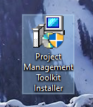To start the installation process, the program’s installer needs to be run. Double click on the following file:
2. The operating system will likely ask for administrator permissions in order to execute the program. Since the project team did not lace the program with malware, clicking on the “Yes” button would have no adverse effects.

Afterwards, the user will be greeted by the screen below:

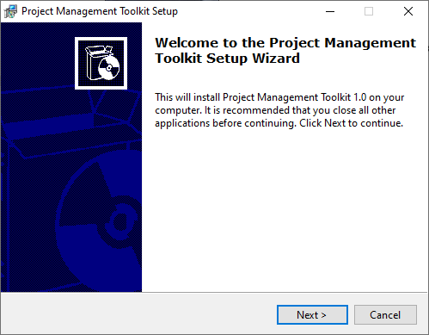

1. To continue with the installation process, the user needs to click on the “Next >”.

Once this button has been pressed, the following screen will appear:

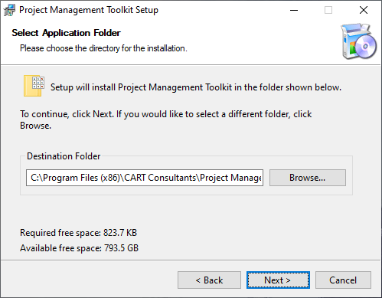

1. From here the user can choose in which directory he/she wants to install the program. The default installation path is highly advised. After the destination folder has been determined, the user can click on the “Next >” button to continue the installation process.

Afterwards, the user will see a progress bar that indicates the installation progress. Once progressbar is filled, the next installation step will commence. No user input is required during this time.

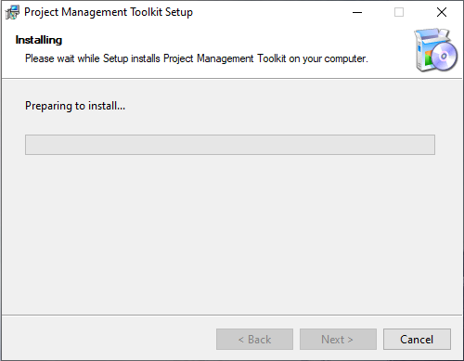

When the installation process has been completed, the following screen will be visible:

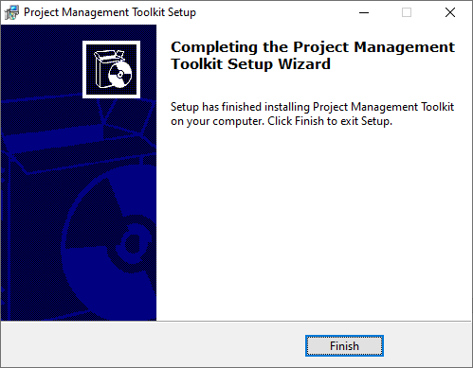

1. This screen indicates that the installation process was completed successfully. To finish the installation process, the user only needs to press the “Finish” button.

This completes the program’s installation and the next section will discuss how the user can create an account in the system as well as how they can sign and gain access to the system.

## Starting up the system

To start using the system simply double-click on the Project monitoring Toolkit icon that was generated by the Installer in the previous section. An icon will be available on your desktop or can be found by using the windows search function. Simply search for “Project Management Toolkit and an icon should appear allowing you to enter the system.

## Logging in

Upon startup, the system will display the window below:

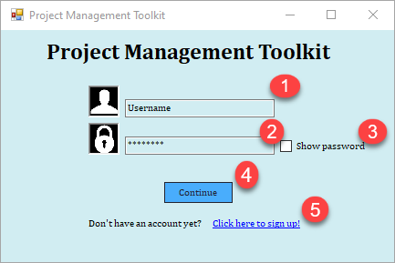

The purpose of the form is to allow the user to provide their username and password to the system, allowing them access to all of their projects and safeguarding any and all private information. The components numbered in the image are discussed below:

1. This component will accept the username from the user and is not case sensitive allowing the user to use both upper and lowercase letters. The username is chosen when you create your account on the signup page and cannot be changed at a later stage so make sure that you write it down in a safe location.
2. This component is used to obtain the password from any users and has special properties that prevent the password from being visible to any onlookers guaranteeing the safety and security of the user's account. This password is chosen when the User creates an account and cannot be changed once set and currently cannot be retrieved without accessing the database directly so please make sure to write this password down in a safe location.
3. If you wish to view the password that you have entered into the password text box simply check this checkbox and the password will be displayed without any filtering. Please be careful when using this feature as onlookers may be able to obtain your password so only use this feature if you are alone or with trusted individuals.
4. Once the username and password have been inserted you can use this button to attempt to enter the system. The username and password will be analysed and compared to the values stored in the system the user will either be redirected to the project Selection page or the User will not be allowed to enter the system and an appropriate error message will be displayed just under the p[assword component and above this button.
5. If you have never created an account on this PC you can make use of this button to be redirected to the Signup page that will be discussed below.

These are all of the main components required to enter the system and to gain access to all of your saved documents. Please note that currently, the database will only contain the information on the accounts that were created on that particular system. If you move the application to another system the Username and password will not be available and you may have to create it again. The next section will walk you through the process of creating a new account.

## Creating an Account

If the user navigates to the SignUp page using component 5 discussed in the previous section they will be greeted by the following screen:

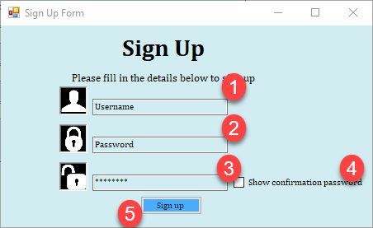

The following page allows users to create their own accounts to gain access to the project selection page and this will allow them to safely link projects to a specific account. All of the components numbered above will be discussed below:

1. This will be the username that you will use to login into the system. The username is not case sensitive and no duplicate usernames will be allowed to ensure that you do not use a username that you have used before if you are creating an additional account. Any errors with the username will be displayed in the space just to the right of the textbox.
2. This component will receive the password for the account that you are trying to create. Please keep in mind that this account password cannot be changed once it has been set so ensure that the password is one that you will remember. Attempt to adhere to strong password principles by including at least one Capital letter and symbol in your password.
3. This component will be responsible for recapturing your password so please ensure that the password you enter here is an exact match for the password that is entered into component 2. Both these fields are Case sensitive so make sure that the case is the same in component 2 and this component.
4. If you wish to view the password that you have entered into the password text box simply check this checkbox and the password will be displayed without any filtering. Please be careful when using this feature as onlookers may be able to obtain your password so only use this feature if you are alone or with trusted individuals.
5. Once you are satisfied with your username and password you can click on this button to save them into the Local database. The passwords and Usernames will be encrypted to ensure their safety and can thus not easily be read by external users. If any errors occur with the password or Username an appropriate error message will be displayed and the user will not be redirected to another page.

Once the above steps have been completed the user should be able to log into the system using their new credentials. The upcoming systems will expand n the functionality of the system and will explain each of the core components of the application.

## The Project Selection and creation page

Once the user has successfully logged into the system they will be provided with the following page:

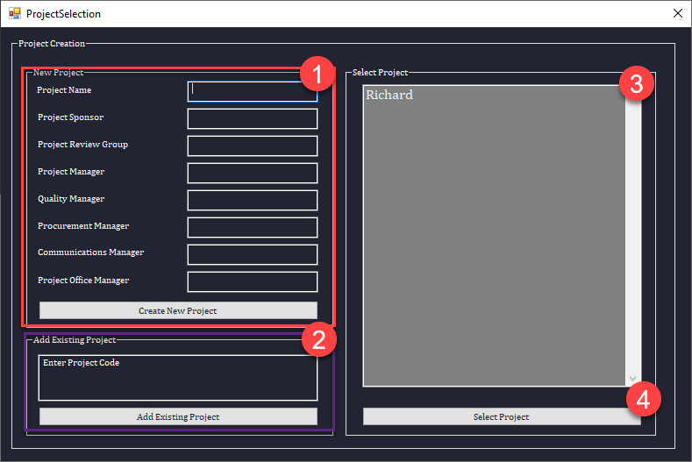

This project selection consists of 4 main components that will be briefly discussed below:

1. This section contains all of the information of any new projects that the user wishes to create. This includes providing information such as the Project name, Project sponsor .and any other relevant information. The system will expect the Project Name and the Project Sponsor to be filled in before a project can be created. Once all of the information has been entered the user can click on the create project button to create their new project. The new project should immediately appear in component 3.
2. If the user would like to join an existing project that has been created by another team member they need only obtain the specific project code from the user that had created that specific project. Once the code has been obtained the user can simply enter the code into component 2 and click the “Add existing project” button and if the project code exists then the user will be added to this project. The project codes are uniquely generated for each project and the likelihood of anyone guessing a project code to gain access to an unauthorized project is highly unlikely. The system currently has no way of exchanging project codes and it is the responsibility of the user to ensure that the project code is safely transferred.
3. This component will display the project names of all the projects that the user is involved with. This will include projects that the user has created as well as projects that have been added using the “add existing project” feature discussed in the previous section. If the user wishes to view more information regarding a specific project they can double click on the project, or can simply click on the “Select project button” as shown in component 4 to move on to the project detail page that will contain various templates and all of the filled documentation for the user to use.

The upcoming section will discuss how the project detail page works that will contain all of the templates that will guide the user through the process of project management and will also provide the user with the opportunity to fill in these templates that will then be synced to the online database and can be viewed by all of the group members.

## Project Detail Page

Once the user has selected a certain page the following page will be displayed:

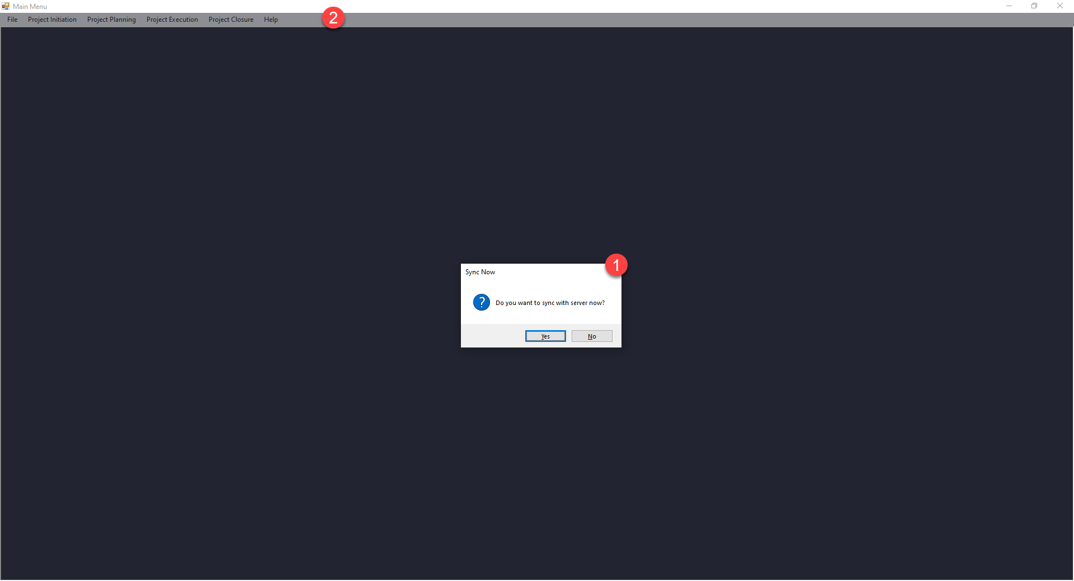

The user is first prompted if they would like to sync all of their data to the online database. This operation will occur every 12 hours automatically but this option allows the user to ensure that the data they are working with is the latest available data. Component 2 in the sketch above displays the various phases that every project will consist of and will contain various tasks that need to be performed in every phase.

The user interface’s navigation is quite simple to follow. The user simply clicks on the phase he/she wants to interact with in the main menu’s toolbar. When this happens, the button will give several options as to what the user can do. For each type of activity/documentation type, the user can choose to fill in a template or to view a filled-in example of this template. The program’s menu structure will now be laid out for each project phase and the user can access the form by simply clicking on the tabs displayed in the image above.

### Project Initiation Tab

### Project Planning Tab

### Project Execution Tab

### Project Closure Tab

# Using the applications project Management features

The following section will assist you with using the project management section of the application and will guide you through all of the components that you may encounter as well as provide tips on how to successfully utilize the system.

## Components used within the system

This section will display all of the components that are used to capture information from the user. You will encounter these on many forms and thus we will not be explaining every form but we will provide you with all of the knowledge required to correctly fill in every form that you may encounter whilst using this application

The following screen displays the components that you will encounter the most when working with the application:

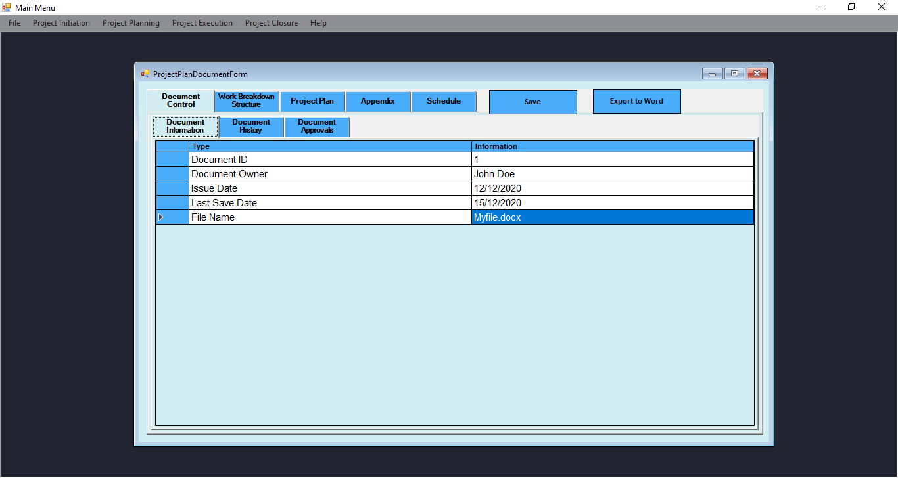

Each document will consist of various components that have been specifically chosen to manage particular tasks. Within each phase, there are various tasks that need to be completed and each activity will have its own forms that can be exported to a word document. These components and their main functions are described below with the numbers displayed in the above image being used to refer to specific components:

1. **Overall Tab control** – these components are used to group related activities on a single window. Each tab on the tab control represents a different activity. The currently selected tab is indicated by a lighter color (for example the Document Control tab). Each tab will have a different set of activities for the user to select that will reload the contents of the window to display the new information that can be filed in for that particular activity.
2. **Embedded tab controls** – they function just like tab controls and are used when an activity may have multiple facets. For example, a document control may require the user to enter a description as well as a list of activities and the application will split these activities into different tabs making it easy for the user to quickly and efficiently locate information without having to search through a large document. The contents of each section will be loaded in from the online database to ensure that the user is always presented with the latest information.
3. **Predefined Table** – this type of table can be filled in in order to provided information regarding specific aspects of an activity. No additional rows can be added to the table and only a set number of predefined fields can be filled in ensuring that no incorrect or unneeded information can be placed into the database. Each table will have its own unique headings to ensure that the correct information is entered into the system.
4. **Save button** – the save button is used to save all of the information on a specific interface to the online database if an internet connection is available. Once the button is clicked the system will only save the content of the window on which it the button is located. If the program or window is closed, the information within it will be available and filled in the next time the same window is opened. When the button is clicked, the following message will be displayed upon successful saving:

If the system experiences any errors when working with the system the user will be notified of the reason for the error and the form will not be saved.

1. **Export to Word button** – this button is used to create a standardised Microsoft Word document containing all of the current Window’s filled in information. A pop-up window will prompt the user to specify a location where the exported document will be saved. It allows the user to navigate to any folder the user has access to. The user can also give the document a name. This window is shown below.

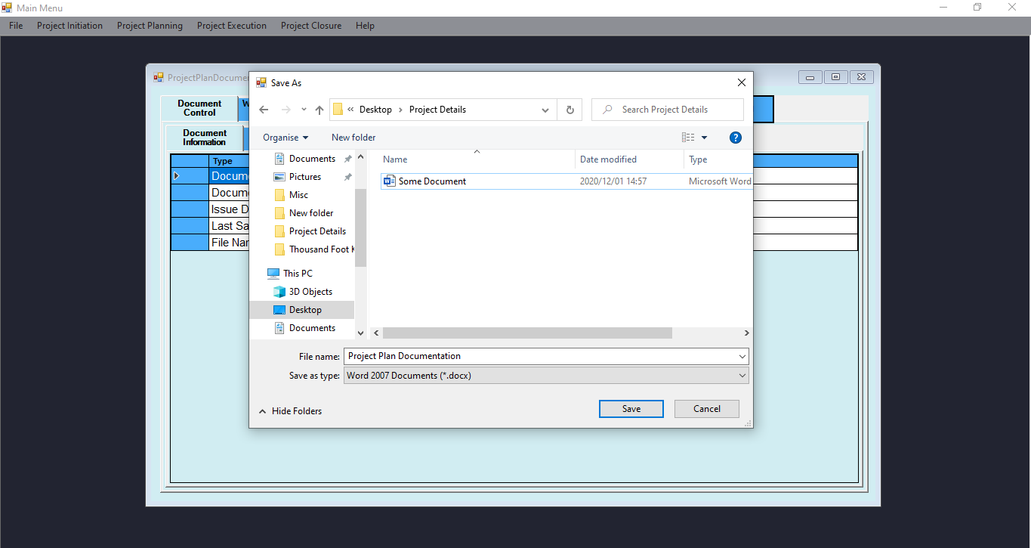

# Opening exported documents

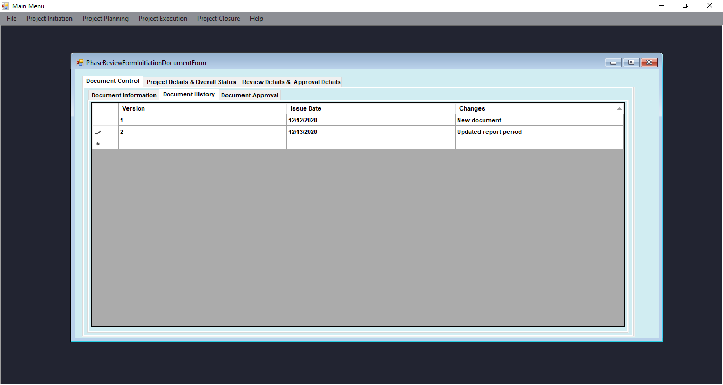The following component presents itself on another interface, will be demonstrated:

1. A **loosely defined table** – contains only column names. The users can then fill in these columns in one or more rows. In order to add a new row, the user needs to select the blank row (indicated with a star * on the left) and fill in the columns in that row. As soon as even a single column is completed in a new row, the row will be added to the document. This component provides scalability to the program and allows the user add any number of rows to a given column.

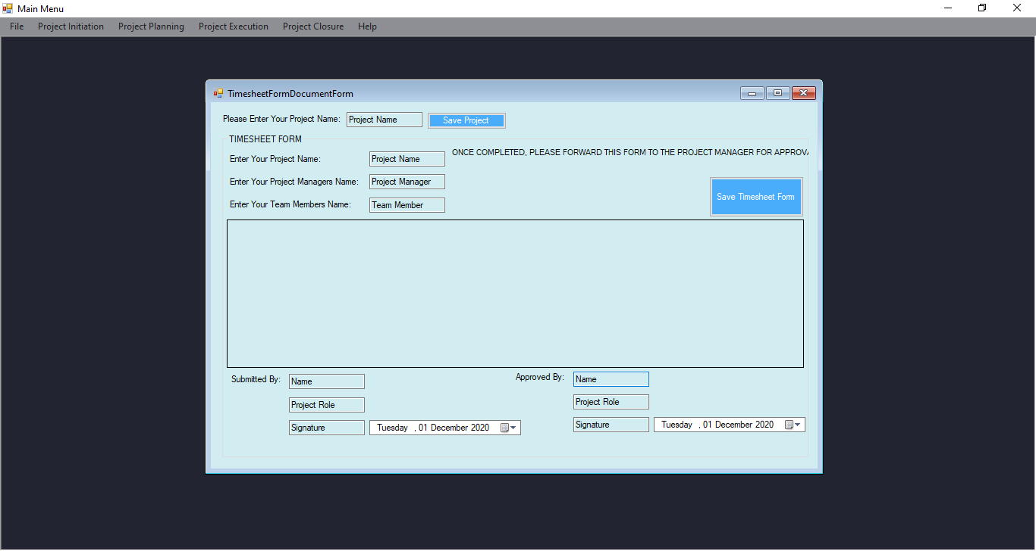The image below displays two additional components that the user may encounter :

1. **Classic textboxes** – the components are very simple and are a variation of the predefined table component. A description is provided to the left of the control. This description indicates what kind of information needs to be provided in the textbox. The user can then click on the textbox and type this information inside of it. There is no validation performed on these components so please ensure that the correct information is filled in before exporting the information to a word document.
2. 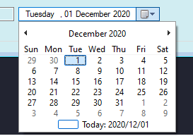A **date selector** – can be used to choose a specific day, month, and year. Once the user clicks on the date selector, the program will present the interactive calendar shown below. The user can then select the date he/she wants to use. If the users want to navigate to another month, the arrow keys on the calendar can be utilized. This ensures that the date formats used across all of the documentation are uniform and that the user need not enter the entire data manually. The user can simply click on the today icon displayed on the bottom of the component to select the current date.

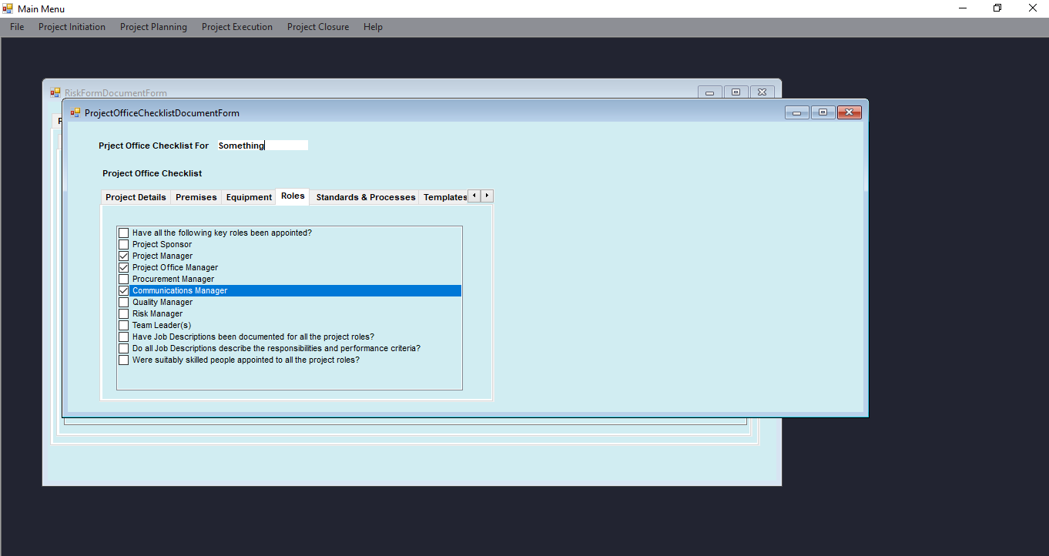Two rarer components that you may encounter during the course of using the application are Tab navigation arrows and Checkboxes. These components are shown in the figure below:

1. **Tab navigation arrows** – these arrows appear when the window is not large enough to display all of the various tabs in a tab control. The arrow keys allow the user to navigate through the available tabs. In order to see all of the available tabs in such a tab control, the window can simply be made bigger by resizing the tab. All of the tabs make use of an anchor feature that ensures that the components on the tab are scaled correctly depending on the size of the tab. For the best possible experience, the advises that the tab be maximized (enabled to full-screen mode) to ensure that as much info as possible is displayed.
2. **Checkboxes** – in some cases, a window may require the user to tick checkboxes to indicate whether something is present or required. A checkbox can be ticked or unticked. This can be done by clicking on the checkbox. At the start of any project, all of the checkboxes will be unchecked and the user must ensure that all of the desired checkboxes are selected to ensure that the correct information is transferred to the documents.

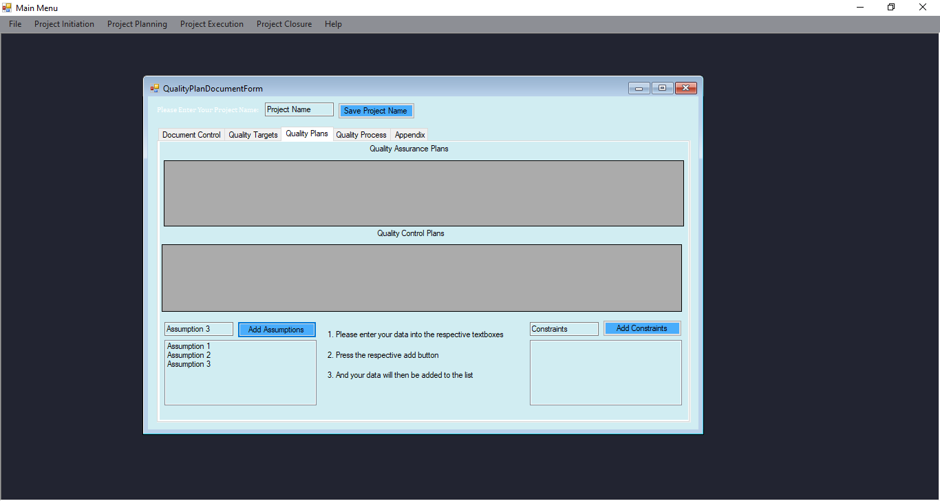The final components that the user may encounter are Lists and Larger Textboxes and the components are discussed and displayed in the section below:

1. 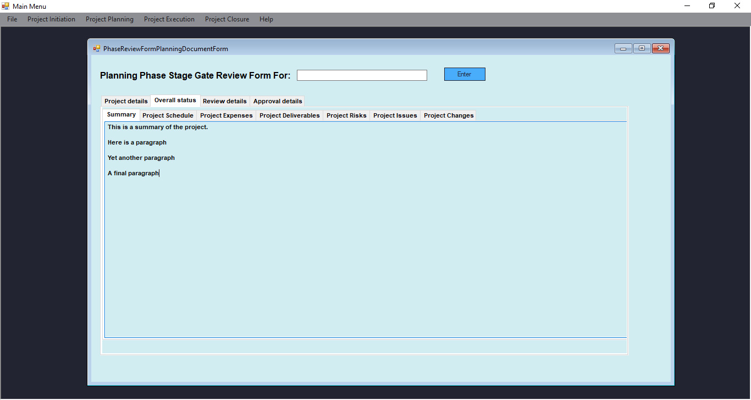**Lists** – on rare occasions, the system will ask the user to create a list of items. The user can then type a list item into the textbox and click on its corresponding button. The item will then be added to the list. Please confirm that the items have been entered correctly into the provided location before adding them to the list of items as it can prove difficult to remove an item once it has been added.
2. **Large textboxes** – some windows require the user to provide entire paragraphs. They allow the user to extensive bodies of text. In order to make paragraphs, the user simply needs to press the “Enter” key to make a new line. This text will be cleared if you do not save all of your work so please ensure that you always click on the Save button to ensure that your work is updated on the global database and that everyone has access to the latest information and documents.

## Printing Documents

Users may want to print the documents that have been generated by the project and this is entirely possible as all of the documents generated by the forms have been exported in a Word document so the user can simply open them in Microsoft Word and use their built-in function to print the desired word document. Microsoft Word has an incredibly handy print shortcut that the User can utilize by pressing both the Ctrl and P keys at the same time. The developers also addd an additional Feature in the Project Home page that allows you to print files directly from the application. If click on the “File>print a file: option in the project main menu You will be provided with the following component:

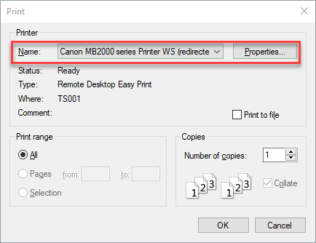

This component will allow you to select your own printer and will allow you to adjust the settings of your printer such as the number of copies or whether single side or double sided printing should be used. Once you are satisfied with the settings simply click on the Ok button and the system will prompt you to select the file that you wish to print. Once a file has been selected it will be printed using the previously selected printer and all of the corresponding settings.

# The suggested process to be followed when utilizing the application.

The following section will provide some general tips and advice for using the system and will walk you through the process of using the entire system. This will provide step by step instructions to ensure that you get the most out of the system.

## Step 1: Log in to the system

The first thing that you need to do is to log in to the system using the username and password that you have created on the signup page. Please remember that the Username is not case sensitive, however, the password is case sensitive and you will not be allowed into the system if your password does not exactly match the password provided on the signup page.

## Step 2: Select the project you wish to work on or create a new project:

Once you have successfully logged into the system the next step is to select a project that you would like to work on. This page is shown in Section 2.6. will allow you to either create an entirely new project or will allow you to select a project that you have already worked on this will take you to the Home page of your project as shown below. This page allows you to entire crucial information such as your project manager, your quality manager, Project Sponsor, and many more crucial positions in the project so please ensure that all of this information is correctly filled in before you create the project. If you wish to join someone else’s project please request their unique project code and enter it into the “add existing project” section. This will add you to the existing project and will give you access to all of the documentation and items stored within the central database

## Step 3: View and edit document contents of each phase

Once you have selected a project you will be provided with the following page that will be used to track the progress of your project and will allow you to edit and view key project information. The home screen will look something like the image below.

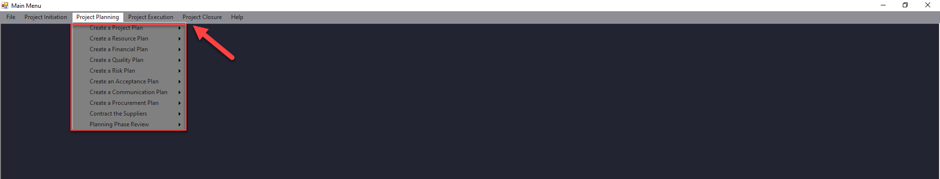

The red arrow above displays the four main phases of any project starting with Project initialization and ending with Project Closure. These are the four main phases as determined by the MPMM project management Methodology and this flow makes it easy to quickly and easily locate any documentation for their particular project. You can click on any of these phases and the system will provide you with all of the tasks that need to be completed in the project. The following image displays a summary of all of the tasks involved in every phase of the project.

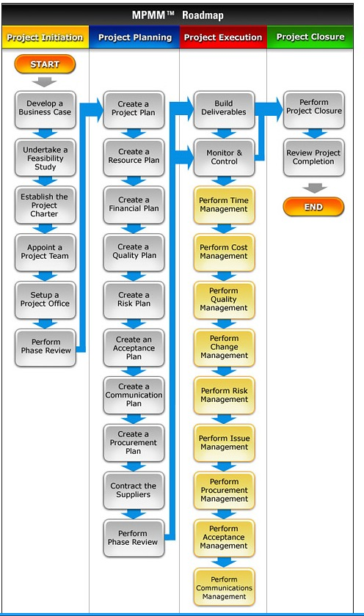

The next step to be taken is to work through each of the four phases and to ensure that each of the tasks within the phases has been completed before moving on to the next phase. Each phase task will provide a template for you to fill in where each of the activities and facets of the task will be provided for the user to fill in.

Once you are satisfied with the template and all of the information that has been filled in you can click on the Save button to save the changes made to a local repository. This information will be kept here until either 12 hours have passed and then the changes that have been made will be sent to the Online database and will be readily available to the user. More information on the syncing will be provided in the upcoming section. An additional feature that has been added is the ability to export the information gathered from the filled-in template into a word document,. Once you click on the “export to Word” button on any of the forms the application will ask you for a place to export the word document and will then populate a Word document with all of the collected information and store it in a fixed location. Currently, the user has to choose where to

## Step 4: Tracking project progress

An additional tab has been added to assist the users with tracking the process of each phase of the project that will contain the name of the phase as well as a progress bar that displays how far the phase is from being completed. The form will also display all of the activities of that particular phase within a table and will make use of checkboxes to show which activities have been completed in the phase and which documents are still missing. The image below displays an example of the report generated for the Project planning phase:

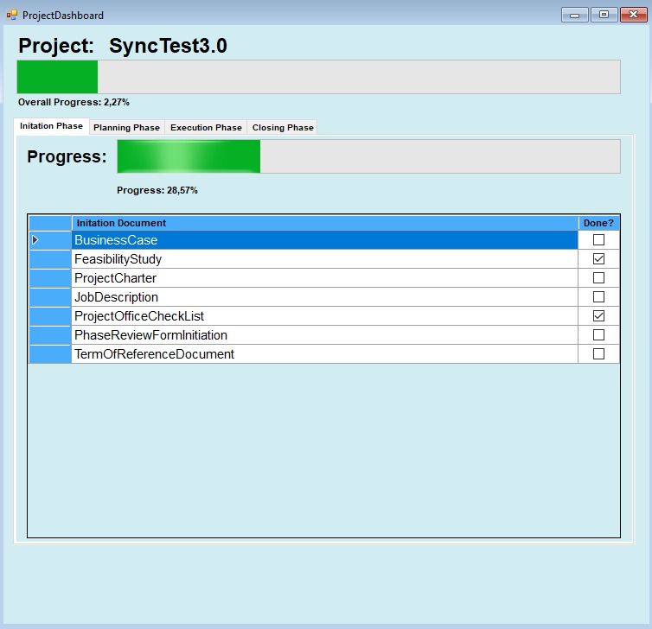

## Step 5: Sync information to Online Database

Once you are satisfied with all of the changes that you have made to the various templates and you have saved the changes locally you have the option to manually sync all of the files to the online database. On the project home screen, you can go to the File tab and click on the sync button where you will be prompted with the following message:

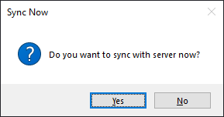

If you have a stable internet connection you can click on the yes button to send all of your changes to the Online Database. The system should automatically do this every 12 hours to ensure everyone has access to the latest available information.

Once all of the phases and all of their activities have been completed the project can be considered complete and the project management tool should now contain all of the information regarding your project. Each phase and its activities will be synced to the server every 12 hours if the device has a valid internet connection and when any other users access the projects they will have access to the latest available information regarding their projects.

# Possible errors that could be encountered

The following section will provide a list of all of the possible errors that you may encounter when using the application as well as having some additional tips and advice on how to fix these problems.

1. **Error Message**: “Username does not exist”

**Possible fix:** This error will occur if you have entered your username incorrectly. Please ensure that the Username is spelled correctly and that you have created an account

1. **Error Message**: “Password incorrect”

**Possible fix:** This error will occur if you have entered your password incorrectly. Please ensure that the password you have entered matches the username in the textbox and that you have spelled the password correctly and that the correct case has been used.

1. **Error Message**: “Username is already taken”

**Possible fix:** This error will occur if you attempt to use a username that already exists on the local device. Simply select another username to get rid of this error.

1. **Error Message**: “Error syncing forms”

**Possible fix:** This error will occur if you attempt to sync forms from the online database without having a proper internet connection. To prevent this error from occurring ensure that you have a strong, stable internet connection and you could also try simply restarting the application. The system will provide you with a list of all the forms that have not synced properly to ensure that you are always aware of forms that have not been updated.

1. **Error Message**: “Error exporting Word document”

**Possible fix:** This error will mainly occur if you are attempting to export to a word document that is currently open. To prevent this error simply ensure that all of your word documents are closed and restart the operation. If the error persists please contact the development team for support.

1. **Error Message**: “You have no local Documents stored”

**Possible fix:** This error can be found on the project Dashboard form and occurs when you have not loaded any documents to your system. Once you save a single template then this error will be automatically removed and you will be able to track the progress of your project in the project Dashboard.

1. **Error Message**: “Excel template Not found”

**Possible fix:** This error will only occur if a certain excel file has been removed from the system files and will generally happen when the system may have installed files in the incorrect locations. To resolve this error simply try using the installer to reinstall the application as this will put all of the excel templates in the correct locations.

If you encounter any additional error messages that cannot be solved using the above methods please contact the project upport team and they will assist you with resolving any issues.

# Conclusion

We hope that ths tool will assist you and your team with completing all of your projects and this tool will most certainly assist you with easily and efficiently managing all of the complex documentation associated with a projects. The application will help keep track of the progress of your projects an allow you to better plan for the future. If you have any questions or commenst on the program please feel free to send them to [Richardteunen2@hotmail.com](mailto:Richardteunen2@hotmail.com) or [ricusw@gmail.com](mailto:ricusw@gmail.com). We thank you for using our application and look forward to seeing the reults of the projects you undertake.